TagData – A Revolutionary Platform for Personal Data Management

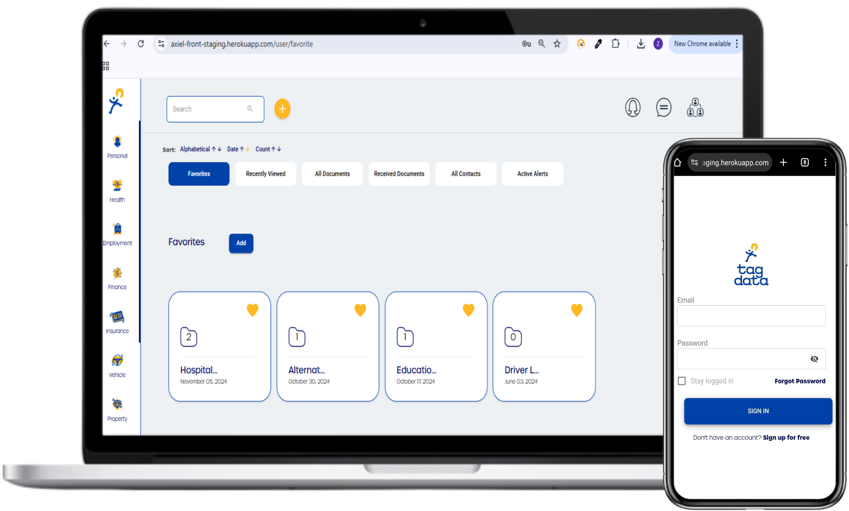

In today's digital landscape, managing personal data across multiple platforms has become increasingly complex. TagData was created as a unified, secure platform where individuals can store, organize, and safeguard their personal digital information. Designed with privacy and security in mind, TagData empowers users to control and protect their Personally Identifiable Information (PII) in a world where data breaches are common.

**Challenges**

The need for a secure, user-friendly solution for managing personal information is growing. With so much PII scattered across various online platforms, individuals are more vulnerable to identity theft and data misuse. Many users feel overwhelmed with managing their digital identity, lacking a central repository for their critical data.

* Scattered Personal Data
* Increased Vulnerability
* Overwhelming Digital Identity Management
* Lack of Secure Storage
* Demand for Privacy and Control

**Solution**

TagData offers a unique solution that centralizes, secures, and manages personal data:

**Data Centralization:** TagData allows users to gather all essential personal information in one place, making it easier to access and control.

**PII Protection:** With a focus on safeguarding PII, TagData offers secure storage, minimizing the risks associated with data exposure.

**Generative AI Integration:** TagData's algorithms analyze users' digital profiles, offering life management insights and support for various life events, enhancing the personalization of the platform.

**Mobile Accessibility:** By mobilizing PII, users can access and manage their information on-the-go.

**Results**

TagData has successfully provided individuals with a streamlined, secure solution for personal data management. Users appreciate the platform's ease of use, as well as its commitment to privacy and data security. The integration of generative AI adds value by helping users make informed life decisions based on their digital identity.

TagData represents the future of personal data management by offering an all-in-one, secure solution for organizing, protecting, and managing personal digital information. As the digital world evolves, TagData's proactive approach to data security and privacy sets a new standard in protecting digital identities.

Images for tagdata.

