WOSH--Revolutionizing Laundry Services with WOSH

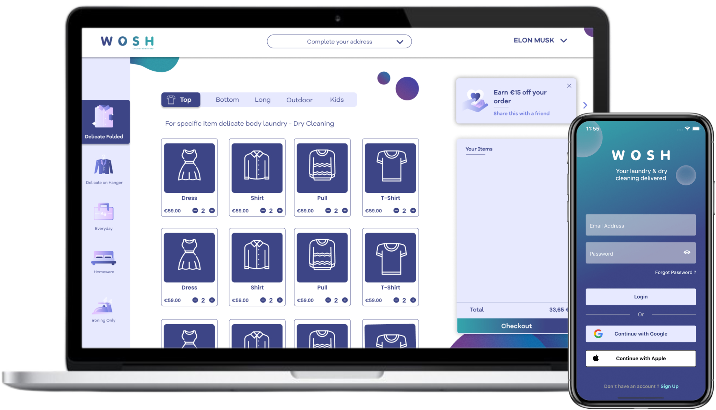

Laundry can be time-consuming and disruptive, especially for busy individuals. WOSH was created to streamline the process, connecting users to local laundry services through a mobile app and web platform, making laundry easy, convenient, and eco-friendly.

WOSH supports both customers and laundry partners, providing tools for efficient order management and communication, ensuring high-quality service and reliability.

**Challenges**

Customers in urban areas face several common laundry challenges:

* Limited Service Hours: Traditional services often operate on fixed schedules.
* Lack of Tracking: No visibility into order status.
* Inconsistent Quality: Varying service levels among providers.
* Environmental Concerns: Desire for sustainable options without sacrificing quality.

**Solution**

WOSH addresses these issues with a 24/7 platform featuring:

* **Easy Order Placement:** Place orders anytime via mobile or web.
* **Secure Payments:** Encrypted, hassle-free transactions.
* **Transparent Pricing:** Upfront rates set by local providers.
* **Real-Time Tracking:** Track orders and view history in-app.
* **Customizable Pick-Up and Delivery:** Flexible scheduling for at-home or collection point services.
* **Eco-Friendly Partnerships:** Collaborates with sustainable laundry providers.

**Results**

WOSH has received positive feedback for its convenience, quality, and eco-friendliness. Users save time, reduce stress, and support local businesses, while laundry providers reach a wider audience through the platform.

**Customer Testimonial**

"Using WOSH has saved me hours each week. The convenience of pick-up and delivery, combined with supporting local eco-friendly laundries, is fantastic!" – Sarah, WOSH User.

**Conclusion**

WOSH redefines laundry by offering a secure, user-friendly platform that emphasizes convenience and sustainability. It seamlessly fits into modern life, making quality laundry services accessible and enjoyable for everyone.

